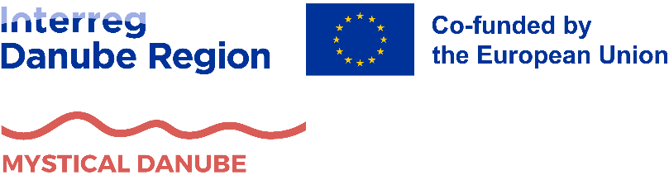


Workshop report for defining objectives, measures and actions for achieving the goals and purposes of the Strategy
MYSTICAL DANUBE
GREEN AND MYSTICAL DANUBE STORYTELLING ROUTE – Transnational valorisation of natural and intangible cultural heritage for socio-economic development of rural areas in the Danube region

Specific objective 1:
Strategy for valorisation of natural and intangible cultural heritage in rural, less visited areas

Activity 1.3
Creating a Strategy on how to valorise mapped natural and associated intangible cultural heritage as a touristic resource for the creation of sustainable community tourism services and products

Content
​
​

1. Guidelines 3
2. Workshop implementation report template 8
3. Template for proposal of objectives, measures and actions of Strategy 10
3.1. The vision 10
3.2. The objectives 11
3.3. Measures & Actions 12

Guidelines
The next step in the implementation of the MYSTICAL DANUBE project is the creation of a strategy on how to valorise mapped natural and associated intangible cultural heritage as a touristic resource for the creation of sustainable community tourism services and products. Official name of that document will be the Strategy for the valorisation of natural and intangible cultural heritage in rural and less visited areas of the Danube Region (hereafter: ‘the Strategy’). The Strategy is envisioned as a key output that will guide sustainable tourism development across the Danube region’s rural and less visited areas. Therefore, the main objective of Strategy development is to develop a joint document on how to transnationally valorise natural heritage sites and associated intangible cultural heritage as a touristic resource with a focus on community-based tourism in rural and less visited areas of the Danube Region. Strategy for the valorisation of natural and intangible cultural heritage associated to the natural heritage in rural and less visited areas of the Danube region will set a model for the valorisation of natural and associated intangible heritage and development of sustainable community tourism and associated services and products with strong community involvement on regional and national level, which will lead to transnational impact of the Strategy. The Strategy will be built on and be able to enrich the EU Strategy for the Danube Region (EUSDR), especially the Priority Area 3 – Culture and Tourism.
Main purpose of the Strategy is to define objectives, measures and actions that will act as a cohesive set of actionable recommendations to ensure that natural and intangible cultural heritage are effectively leveraged as development resources, particularly in the form of community-based tourism services and products. It is necessary to build this Strategy upon the results of Action 1.1. Mapping and collection of natural and associated intangible cultural heritage in the project's rural and less visited areas on which the Strategy will be based and Action 1.2. Mapping and analysis of examples of good practices in the Danube and broader region on projects and activities that deal with sustainable community tourism development. Database across the Danube region, best practice examples and transnational cooperation of project partnership will result in Strategy for the valorisation of natural and intangible cultural heritage in rural and less visited areas of the Danube region. Through the Strategy it is also important to promote sustainability and circular economy wherever possible because the circular economy model can emphasize resource efficiency, reduced waste and prolonged product lifecycles, essential for achieving climate neutrality and safeguarding natural resources.
Each project partner plays a vital role in shaping this Strategy. Each partner developed a Territorial Analysis (Action 1.1.) by providing local data and sharing information from the mapping and analysis phase. This step involved the state of both natural and intangible cultural heritage, as well as current practices in their sustainable valorisation. Those information will be summarised in the Strategy to gain a ‘big picture’ for whole Danube Region. However, main conclusions from each partner can be used as a foundation to propose objectives, measures and actions. Each partner will also develop a Mapping and analysis of good practices (Action 1.2.) which will showcase examples of successful community-based tourism initiatives and heritage valorisation projects that can be adapted or replicated in the context of Danube Region. Results of good practices mapping and analysis will be used as motivation and inspiration for the preparation of our Strategy. Drawing on these previous research activities, together with stakeholder consultation process and results, partners will suggest how to boost sustainable and foster community-led development. This will be manifested through proposal of objectives, measures and actions for the Strategy from each partner. This template was prepared to support project partners in their proposal development.
During the drafting process, all project partners will conduct workshops and meetings in their countries with various stakeholders (e.g., local, regional and national decision-makers, sectoral agencies, NGOs, SMEs, local community, as well as relevant PA3 stakeholders and project partners) to discuss the results of Activity 1.1 and proposed best practices from Activity 1.2 and translate these results into concrete actions that will valorise natural and associated intangible cultural heritage as a touristic resource in rural, less visited areas in the Danube region. Recommended methodology and the format of these meetings and workshops is focus group, in combination with interviews or questionnaires to gather best possible inputs from relevant stakeholders. For example, you can use focus group for regional level stakeholders, and interviews/questionnaire for national level stakeholders. Partners should use the format that best suit them for structuring the proposal of objectives, measures and actions. It is very important that proposals for measures and actions come from stakeholders as much as possible, in order to maximise the participation and transparency of our Strategy. Some of examples are shown in table.
The partners are free to use any the form of methodology that suits them for drafting the proposal of objectives, measures and actions by the stakeholders. Project partners can adapt the methodology to their needs and can be free and flexible in their approach. It is important to achieve the target result, which is the proposal of objectives, measures and actions with stakeholder engagement.

Tab. 1. Some method ideas for stakeholder consultation process
Focus Group  (recommended) | Focus Group is a participatory method used to gather in-depth insights on a specific topic by facilitating a structured discussion among a small group of participants. Typically consisting of 6–12 individuals with diverse perspectives, a focus group is led by a moderator who guides the conversation using open-ended questions. The method encourages participants to share opinions, experiences, and ideas in a dynamic and interactive setting. The discussion can reveal patterns, motivations, and potential solutions that might not emerge in individual interviews or surveys. Focus groups are particularly effective for testing concepts, evaluating policies, and understanding community needs, making them a valuable tool for participatory decision-making and strategic planning.
Design Thinking | Design Thinking is a participatory method that focuses on solving complex problems through a user-centered, iterative approach. It encourages collaboration among diverse stakeholders and involves five key stages: Empathize, Define, Ideate, Prototype, and Test. The process begins with understanding users' needs and challenges (Empathize), followed by defining the core problem (Define). Participants then generate creative solutions through brainstorming (Ideate), develop tangible representations of ideas (Prototype), and refine them based on feedback (Test). Design Thinking fosters innovation by prioritizing experimentation, adaptability, and active engagement, making it an effective method for co-creating strategies, policies, and sustainable solutions in participatory processes.
World Café | World Café method is a participatory group method designed to foster open dialogue, collaboration and knowledge exchange among participants (regardless of their main sector). It creates an informal and welcoming atmosphere, resembling a café setting, where small groups engage in focused discussions on specific topics at different tables. Each table has a host who facilitates the conversation and records key insights together with participants on a flipchart paper (or any kind of preferred media). After a set period, participants rotate to new tables, bringing fresh perspectives, while the host remains to summarize previous discussions for the newcomers. At the end of the rotation rounds, host present the results of their tables and all participants are free to join the discuss. This iterative process enables collective learning, deepens understanding, and encourages the development of innovative solutions through dynamic interaction. The World Café is widely used in strategic planning, education, research and policy development, as it promotes creativity, engagement, and inclusive participation.
Vision Factory | The Vision Factory is a participatory method designed to collaboratively create future visions, strategies, or projects by engaging diverse stakeholders in a structured, creative process. Participants work together in small groups to generate ideas, discuss different perspectives, and develop a shared vision for a specific topic. The process often includes brainstorming, visualization techniques, and structured discussions to refine concepts and identify actionable steps. By encouraging open dialogue and integrating various viewpoints, the Vision Factory helps to foster collective ownership, innovative solutions, and a clear roadmap for future initiatives.

There are few horizontal topics that each project partner should consider while preparing the proposal of objectives, measures and actions. To be aligned with circular economy principles, the Strategy should incorporate actions that minimise environmental impact while maximizing resource efficiency. Therefore, through the actions, project partners should also include activities that encourage the principles of re-use, repair and recycle, while reducing the pressure on natural resources and reducing waste. Project partners should promote eco-friendly infrastructure, green mobility solutions and tourism services that align with climate-neutral goals, contributing to the climate neutrality. Since the project is focused on community-based tourism initiatives, proposal of objectives, measures and actions should seek to support local communities by strengthening local capacities, especially among vulnerable groups defined by the project (youth, elderly, minorities, women and people with disabilities) and defined in the toolkit on the inclusion of target groups (see Activity 2.2.). Project recognises that for the valorisation of intangible cultural and natural heritage and its use to increase the well-being of local communities is necessary to implement capacity-building activities of local community stakeholders. Proposed objectives, measures and actions should be socially inclusive and environmentally sustainable.
The Strategy will be hierarchically structured with one joint vision of Danube Region and the ‘pyramid’ of integrated objectives, measures and actions. Vision will represent the overarching, long-term ambition that partners want to achieve with the Strategy. It will capture the shared aspiration for how natural and intangible cultural heritage can boost sustainable development, community wellbeing and cross-border cooperation throughout the Danube Region. That vision will help us to structure few main objectives that will serve as strategic priorities on target areas that contribute to realisation of the vision. For example, one objective might focus on community empowerment, another on infrastructure improvements, another on joint heritage interpretation, and so on. Splitting the Strategy into distinct objectives helps ensure that all critical aspects of heritage valorisation are addressed in a structured manner. Within each objective, few measures will be prepared as a sub-goals or a specific approach format that breaks the broader objective into more manageable parts. Measures provide clearer direction and make it easier to track progress toward each Objective. For example, measures can help clarify the question ‘how?’ behind each objective (focusing of stakeholder capacity-building, developing green tourism products, etc.). Each measure will define actions as concrete tasks or interventions that will be carried out to achieve the measure. Actions transform high-level ideas into tangible steps and they are essential for implementation and monitoring. For example, if one measure is ‘Train communities in eco-friendly tourism services’ then one of the actions may be ‘Organise an online training course for guides on sustainable tour operations’ etc. By integrating this hierarchical structure, Strategy could better align transnational vision to concrete tasks, while also ensuring flexibility and adaptability to different frameworks. This structure is also effective in monitoring and evaluation of strategic outcomes.
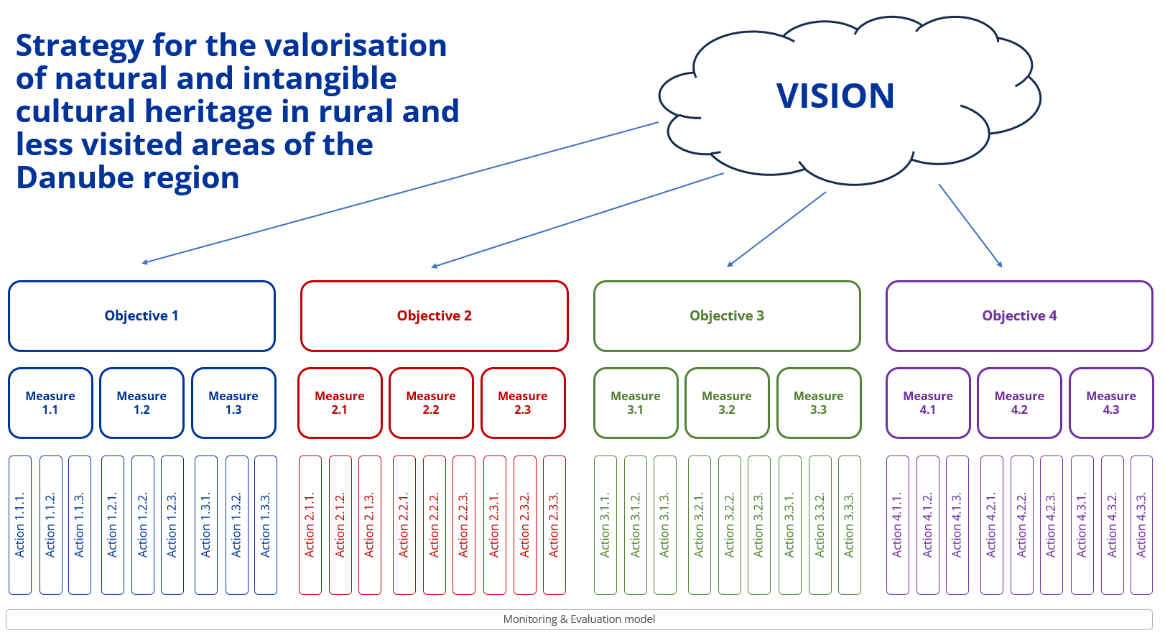
Hierarchical structure of objectives, measures and actions of the Strategy
For example, objectives, measures and actions can be:
Objective 1 - Strengthen capacities for sustainable community-based tourism development
Measure 1.1. – Enhance skills and knowledge among stakeholders
Action 1.1.1. Organise training workshops on sustainable tourism and heritage interpretation
Action 1.1.2. – Create an online resource hub for featuring best practices, practical tools and case studies on sustainable community-based tourism
…
Measure 1.2. - …
Objective 2. - Enhance the preservation and promotion of natural and intangible heritage for sustainable tourism
Measure 2.1. - Strengthen heritage protection and sustainable site management
Action 2.2.1. - Introduce eco-friendly interpretation models at key natural/cultural sites
Action 2.2.2. – Pilot a ‘cultural heritage guardians’ program
…
Be creative!

By the end of the drafting process, project partnership will have a transnationally coherent strategy reflecting the collective insights and data from all project partners, highlighting both common challenges and localized opportunities. Strategy will have actionable recommendations with clear objectives, measures and actions that stakeholders can use to develop new tourism products, services and policies in rural and less visited areas of the whole Danube Region.
The document with the results must be submitted in word format (open format).
The deadline to submit the results is September 15th 2025. We encourage partners to deliver earlier, if possible, so that project activities can be completed on time and with high quality!

Priority Areas
In order to ensure a structured and comprehensive approach to the development of the strategic framework for the Mystical Danube Strategy, all project partners are required to consider the following priority areas/themes during their consultation workshops with local stakeholders. These themes have been identified through territorial analysis and are crucial for the valorisation of natural and intangible cultural heritage in the transnational context.

Key Considerations for Workshops:
- Alignment with Priority Areas
  - The workshops should focus on defining objectives, measures, and activities within the following priority areas:
    - Nature Conservation
      - Protected areas, Natura 2000 sites, Emerald network, OECMs
      - Restoration and protection of natural habitats and biodiversity
      - Climate change adaptation measures for natural heritage
      - Sustainable management of water resources in the Danube region
    - Cultural Heritage Conservation
      - Preservation and promotion of tangible and intangible cultural heritage
      - Development of innovative approaches to cultural heritage interpretation
      - Strengthening the role of local communities in heritage preservation
    - Sustainable Tourism Development
      - Diversification of tourism offers in line with sustainability principles
      - Strengthening cooperation between tourism and heritage sectors
      - Development of eco-friendly tourism initiatives
    - Community-Based Tourism Development
      - Involvement of local communities in the tourism value chain
      - Support for local entrepreneurship and small businesses
      - Promotion of traditional crafts, gastronomy, and local experiences
    - Rural and Less-Visited Areas development
      - Enhancing local identity and attractiveness for visitors
      - Encouraging sustainable economic activities in rural areas
      - Addressing depopulation and socio-economic challenges
For each of these areas, the following aspects should be discussed:
  - Why is it important for the valorisation of natural and intangible cultural heritage?
  - Glimpse at the current situation and desired future state.
  - Infrastructure development: accessibility to cultural and natural heritage sites, sustainable mobility solutions in rural and less-visited areas, development of green and smart infrastructure, etc.
  - Examples of good practices: Choose 1 to 2 examples that align with the desired future state (from research or other partners) to serve as inspiration.
  - Objectives, measures, and activities to achieve the desired state on regional, national, and macro-regional levels.
- Structured Discussion Approach
  - Ensure that discussions with stakeholders address the above key aspects for each priority area.
  - Encourage interactive discussions and knowledge sharing to refine the strategic framework.
- Collection of Relevant Inputs
  - Partners should collect qualitative and quantitative inputs from stakeholders, ensuring that the information gathered is relevant and applicable.
  - Encourage stakeholders to provide specific examples of activities and potential challenges they foresee in implementing the proposed measures.
- Ensuring a Multi-Stakeholder Perspective
  - Engage diverse stakeholder groups, including representatives from local authorities, tourism operators, cultural organizations, environmental agencies, and community groups.
  - Ensure that discussions are inclusive and consider different perspectives, fostering a collaborative and holistic approach.
By following these guidelines and incorporating the outlined priority areas, we will ensure that the strategic framework is built on a solid foundation of stakeholder input and aligned with the overarching goals of the Mystical Danube Strategy.

Workshop implementation report template
Please fill in the table below with information about the workshop(s) you conducted from which you gathered the ideas and inputs for the proposal of objectives, measures and actions of our Strategy. It is very important that proposals for measures and actions come from stakeholders as much as possible, in order to maximize the participation and transparency of our Strategy. If there was more workshops, please copy and multiply the table below. If you used another methodology than workshops, please explain it in the last row.
Name of the partner | Agencija za upravljanje zaštićenim područjima Podgorice AUZP
Name of the workshop | Consultation Workshop for the Strategy Development “MYSTICAL STORIES OF THE DANUBE GREEN ROUTE”
Workshop location | Podgorica, Red Cross meeting room
Date of workshop implementation | May 13, 2025
Temporal length of the workshop  (for example, 2 hours, 3 hours, etc.) | 4 hours and 30 minutes
Total number of participants | 13
Stakeholders involved  (Name the involved stakeholders that were included into implementation, e.g. decision-makers, NGOs, SMEs, local community, …) | Relevant institutions for cultural heritage, representatives of the municipalities of Andrijevica and Kolašin and Capital City Podgorica, Komovi Nature Park, local tourism organizations, civil society representatives, tourist guides
Workshop methodology  (Explain the methodology you used to achieve the results. Max. 100 words.) | The workshop used the working groups method, where participants were divided into three groups, each addressing one of the three strategic objectives. Each group analyzed proposed measures and actions under their objective, suggested improvements, and identified key stakeholders for implementation. Results were presented and discussed in a plenary session to reach shared conclusions.
Workshop results  (Explain the results you achieved through methodology. Which objectives, measures and actions participants proposed? No limitation for words.) | Participants expressed support for the proposed strategic objectives. Through group work, measures were validated, concrete action proposals were formulated, and potential stakeholders were identified. Special emphasis was placed on the need for capacity building of households, improved networking, and greater involvement of women and youth. The group selected a vision that merges versions 2 and 3.
Supportive methodology  (Explain the additional methodology you used to support the workshops, such as interviews or questionnaires. Explain the results..) | Several previous events provided significant input for the design of the strategy, including the Territorial Analysis (Activity 1.1), the compilation of Good Practices (Activity 1.2), the SWOT analysis, the rapid tourism assessment (rTAT), and thematic workshops on tourism resources and tools. These activities involved a wide range of stakeholders and generated substantial content that served as the foundation for defining the strategic vision, objectives, measures, and actions. The workshop held on 13 May 2025 functioned primarily as a validation mechanism, allowing local stakeholders to review, comment on, and refine the proposed content. This ensured a participatory and inclusive process, grounded in prior evidence and consistent community engagement.
Additional information
(If you conducted different methodology than workshops, please provide us with that information. If no, leave it blank.)

Please provide us with few photos from your workshops below this text.
PHOTOS:
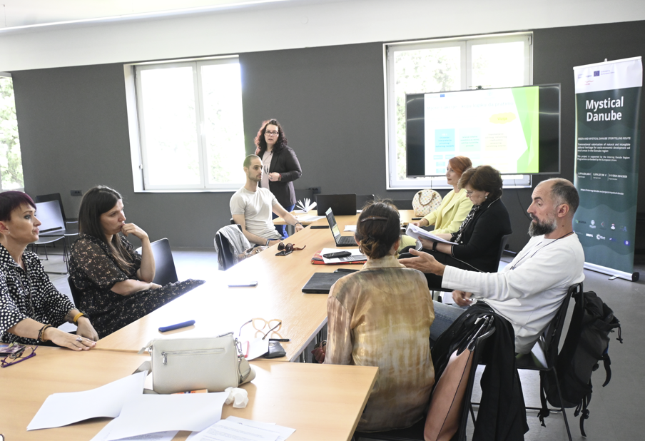

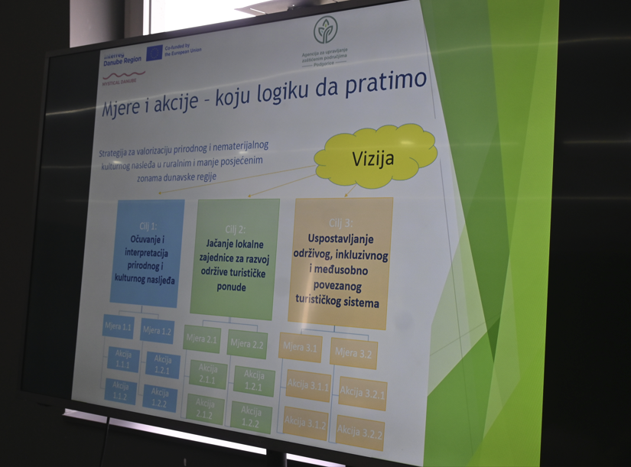
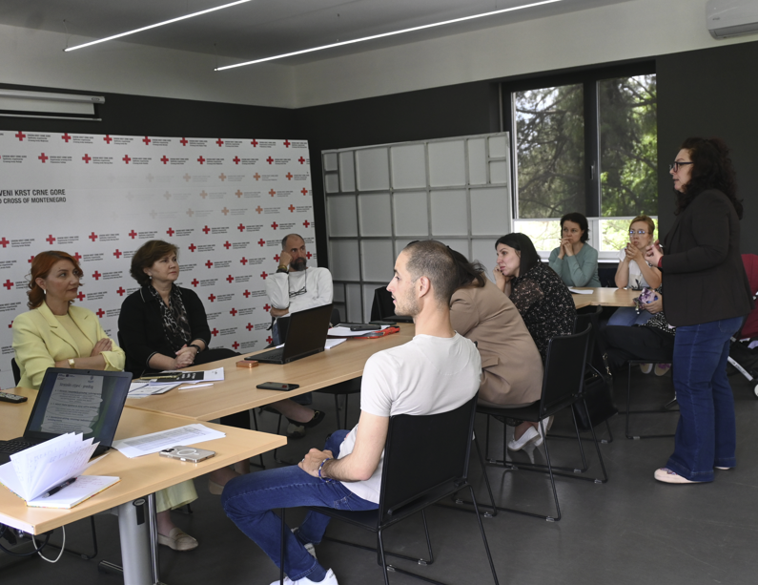
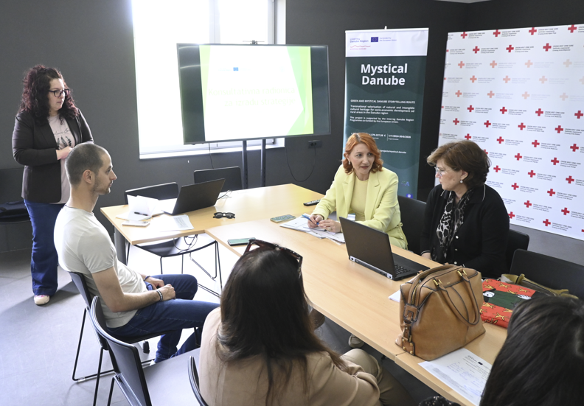
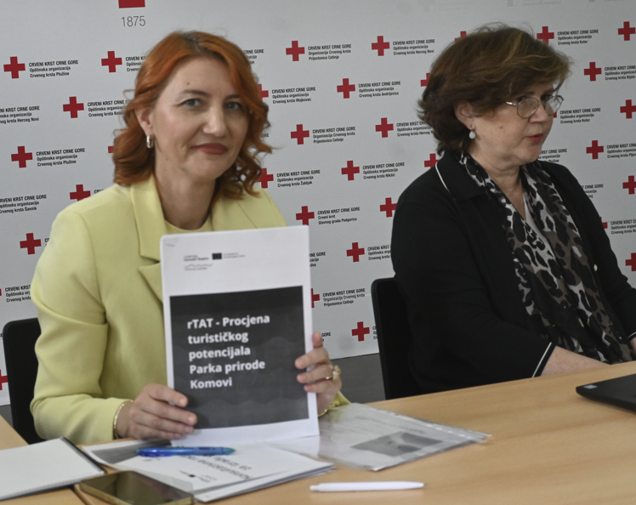

Proposal of objectives, measures and actions of Strategy

The vision
Based upon the results of Territorial Analysis, Mapping of Good practices and stakeholder consultation (workshop implementation), please propose a clear, overarching vision – a statement describing the long-term ambition for rural and less visited areas of the Danube Region. The statement should reflect how natural and intangible cultural heritage can be integrated into community-based tourism which could boost sustainable development, community well-being and cross-border and transnational cooperation.
Vision proposal:
Komovi – a destination of preserved nature and living traditions, where tourism is developed in harmony with the local community, respecting cultural identity, supporting local livelihoods, and enriching the experience of every visitor.
Please, explain why you chose that vision and what motivated you to create such a vision from the results of your previous activities within the project (1.1., 1.2., stakeholder consultation, etc.)? (max. 200 words)
This vision was formulated through a participatory consultation process held with local stakeholders during the strategic workshop. Participants reviewed three proposed vision statements and decided to merge elements of two — recognizing the need to safeguard both biodiversity and cultural heritage while also empowering local people to be active drivers of tourism development.

The vision reflects key project values: sustainability, authenticity, inclusion, and balanced development. It provides a shared long-term direction for aligning tourism initiatives in the Komovi area with the broader goals of the Mystical Danube project and the EU Strategy for the Danube Region.

The objectives
Identify few main objectives that could help achieve your proposed vision. Each objective should focus on a strategic priority that is important for MYSTICAL DANUBE thematic scope, but also to the supportive topics. Please explain how each objective supports the Vision and how addresses needs and potential identified in Actions 1.1. (Territorial Analysis) and 1.2. (Good Practices) or highlighted through the stakeholder consultation (workshop(s)). There is no limitation on number of proposed objectives.
PROPOSED OBJECTIVE | EXPLANATION  (max. 200 words each)
Objective 1.: Safeguard and interpret natural and cultural heritage of Komovi | This objective directly supports the vision by focusing on the preservation and active interpretation of the region’s most valuable assets – pristine nature, traditional knowledge, and transhumant cultural landscapes. It aligns with the findings of the Territorial Analysis, which emphasized Komovi’s ecological value, biodiversity, and unique cultural expressions such as katuns and seasonal migration. Good Practices such as the KATUN project and the cross-border architecture initiative have shown the relevance and potential of preserving traditional forms through tourism. Stakeholders at the workshop strongly supported this objective, suggesting thematic trails, interpretive materials, and seasonal events as key actions. Protecting and showcasing heritage will not only reinforce the identity of Komovi but also provide authentic experiences for visitors.
Objective 2.: Empower local community for sustainable and inclusive tourism development | This objective reflects the community-driven spirit of the agreed vision. It addresses one of the key challenges identified in SWOT and rTAT analyses — low capacity among rural households despite their high motivation. The Territorial Analysis highlights depopulation and weak service infrastructure as long-term risks, while the workshop consultations confirmed strong local interest in participating in tourism. The objective promotes training, mentorship, and inclusive participation, especially of women and youth, as highlighted in the Good Practices (e.g. Invisible Women of Montenegro, Gastro Route). By building local skills and networks, the Komovi area can ensure that tourism benefits remain in the community and that locals are key actors in shaping tourism.
Objective 3.: Establish a coordinated, connected, and environmentally responsible tourism offer | Komovi lacks a unified tourism structure, as confirmed by both the Territorial Analysis and stakeholder input. This objective aims to develop mechanisms for coordination (e.g., working groups, regular meetings), integrate offers into routes, and ensure that sustainability principles are respected. It responds to the Danube Strategy’s call for regional integration and green development, while reflecting workshop feedback on the need for shared branding, better coordination, and environmental care. This objective also links to circular economy principles — supporting local production, reducing waste, and encouraging ecological innovation (e.g., composting, renewable energy). It draws on good practices like the Hiking & Biking Initiative and CZIP’s digital tools to enhance visibility and connectivity.

Measures & Actions
For each objective that you proposed in previous chapter, please propose few measures that you find the most important for achieving the ideal outcome. For each measure, please propose a list of possible actions (concrete tasks or interventions), as explained in first chapter. Focus on the measures that emerged as needs and potentials based on your previous activities in Actions 1.1. (Territorial Analysis) and 1.2. (Good Practices), as well as on inputs gathered through stakeholder consultation process (workshops). It is very important that proposals for measures and actions come from stakeholders as much as possible, in order to maximize the participation and transparency of our Strategy. The results will be interpolated between the project partners and a joint strategic framework will be developed based on your inputs. The total number of proposals for measures and actions is not limited and each partner can enter as many inputs as they wish. The more ideas we collect as a partnership team, the better the Strategy will be.
Please note that according to the AF, some activities must be implemented by the end of the project implementation, while others may be long-term and may be implemented in the future. Also, an implementation scope needs to be defined for proposals. For the implementation of activities on the ground, the entire partnership should cover areas at the project level: regional, national and macro-regional/transnational.

OBJECTIVE 1.: Safeguard and interpret natural and cultural heritage of Komovi
Proposed measure  (please propose few measures) | Implementation scope  Insert implementation scope: regional, national, macro-regional/ transnational | Description  What is this measure aiming to achieve? Why did you propose it? (Max. 100 words) | Relevance  How does it help fulfil the corresponding objective? (max. 100 words) | Potential impact  Expected benefits for local communities, heritage conservation, environment, cross-border and transnational cooperation etc. (Max. 100 words) | List of actions for proposed measure  (please propose few actions that might be implemented to achieve the results of measure you proposed. Add more lines if needed). | Inclusion of vulnerable groups (Yes/No)  (If applicable, indicate how this action will engage or benefit vulnerable groups, max. 100 words) | Link to previous activities  Whenever possible, reference key findings from your Territorial Analysis (mapping of heritage), the Good Practices Analysis (models or case studies that inspire your measures/actions) and the stakeholder consultation process you conducted. (Max. 100 words.)
- Develop thematic trails and interpretation infrastructure | Regional | This measure aims to physically mark and interpret key cultural and natural landmarks (e.g., katuns, sacred sites, biodiversity hotspots). It builds on rTAT recommendations and the Tourism Tools Workshop. The aim is to enhance visitor experience while educating them about heritage. | This measure directly supports the vision by enhancing visitor experiences while safeguarding key elements of natural and cultural heritage. It addresses the need to make heritage more visible and understandable, identified through territorial analysis and stakeholder consultations. | The measure will increase the attractiveness and accessibility of the Park, disperse visitor flows across more areas (reducing pressure on key points), and foster learning through interpretive elements. It strengthens both tourism and conservation goals. | - Action 1.1.1: Marking and equipping at least 3 thematic trails (Katun route, Marko Miljanov route, and a nature trail through protected zones)  - Action 1.1.2: Installing information boards and QR codes with heritage interpretation | Local youth and women can be engaged in trail guiding, storytelling, and maintenance, while elderly residents can contribute historical narratives and oral heritage. | Identified as a priority in:  - SWOT analysis (need for improved interpretation and infrastructure)  - rTAT report (thematic trails proposed)  - Tourism product workshops (stakeholders confirmed interest in these trails)  - Good practices (katun roads)
- Preserve and valorise intangible heritage | Regional/national | Focused on transhumance, storytelling, local knowledge, and customs, this measure promotes activities like oral history collection, cultural festivals, and community storytelling. It is directly linked to Good Practices from katun revitalization projects and the SWOT’s identified strengths. | The unique intangible heritage of the Komovi region — especially related to transhumance, traditional stories, and seasonal festivals — is under threat due to depopulation and lack of promotion. This measure ensures their documentation, visibility, and transfer to future generations. | Valorising intangible heritage strengthens cultural identity, offers authentic visitor experiences, and supports event-based tourism in low season. | - Action 1.2.1: Documentation and public presentation of stories on transhumance, legends, and key local figures  - Action 1.2.2: Organizing the “Days of Katun” festival as a revival of Ilindan traditions | Elderly residents as heritage bearers, women in event organization and traditional crafts/food, and youth in storytelling and digital archiving. | - Good Practice examples (festivals, storytelling, valorisation of transhumance)  - SWOT analysis (intangible heritage listed as key cultural resource)  - Territorial Analysis (recognition of transhumance heritage value)
- Engage youth in heritage protection and education | Regional | Inspired by ideas from the tourism tools workshop, such as “Mladi rendžeri Komova,” this measure encourages youth involvement through school cooperation, eco clubs, and field-based educational programs. | Raising awareness and engaging youth is essential for long-term preservation of the park’s values. This measure fosters environmental stewardship and cultural pride among the next generation. | Helps create a future local workforce sensitised to sustainability and tourism, and builds bridges between schools and protected area management. | - Action 1.3.1: Establishment of the “Young Rangers of Komovi” program  - Action 1.3.2: Cooperation with schools for field classes in the Park | Encourages participation of students from rural schools, girls and boys equally, and promotes inclusive outdoor education | - Tourism Tools Workshop (concept of youth rangers proposed)  - Stakeholder consultations (education as long-term investment in protection)

OBJECTIVE 2.: Empower local community for sustainable and inclusive tourism development
Proposed measure  (please propose few measures) | Implementation scope  Insert implementation scope: regional, national, macro-regional/ transnational | Description  What is this measure aiming to achieve? Why did you propose it? (Max. 100 words) | Relevance  How does it help fulfil the corresponding objective? (max. 100 words) | Potential impact  Expected benefits for local communities, heritage conservation, environment, cross-border and transnational cooperation etc. (Max. 100 words) | List of actions for proposed measure  (please propose few actions that might be implemented to achieve the results of measure you proposed. Add more lines if needed). | Inclusion of vulnerable groups (Yes/No)  (If applicable, indicate how this action will engage or benefit vulnerable groups, max. 100 words) | Link to previous activities  Whenever possible, reference key findings from your Territorial Analysis (mapping of heritage), the Good Practices Analysis (models or case studies that inspire your measures/actions) and the stakeholder consultation process you conducted. (Max. 100 words.)
- Training and mentorship for rural households | regional | This measure aims to equip local families with the knowledge, skills, and guidance needed to engage in rural tourism. Through a combination of group trainings and tailored mentorship, it supports the development of quality services and business planning, particularly in underserved and remote areas. | Rural households show growing interest in tourism, but often lack the practical skills, service quality, and long-term planning necessary for success. This measure supports them with concrete knowledge and guidance. | Improved service quality, stronger confidence and capacity among families, diversification of income, and higher retention of youth and women in rural areas. | Action 2.1.1: Organization of trainings in hospitality, household management, and marketing  Action 2.1.2: Individual mentorship and development of business plans for interested families | Particular focus will be placed on reaching women-headed households, elderly rural residents, and young returnees who need support to start a rural business. | Link to Previous Activities:  SWOT analysis (highlighted need for capacity building)  rTAT rapid assessment (identified knowledge gaps and need for tailored support)  Workshop feedback (participants explicitly requested training and mentorship)
- Activation of women and youth in tourism development | regional | This measure focuses on empowering women and youth to take active roles in shaping tourism experiences. It supports creative expression, income generation, and leadership through workshops, product development, and promotional activities based on local traditions and culinary heritage. | Women and youth are underrepresented in rural tourism decision-making and income generation, yet they hold key skills in crafts, cuisine, digital tools, and innovation. | Unlocking this potential leads to new tourism products (souvenirs, workshops, food experiences), more inclusive communities, and cultural revitalization. | Action 2.2.1: Support for creation of souvenirs, handicrafts, and interior design rooted in tradition  Action 2.2.2: Engagement of women in promoting local gastronomy and leading cooking workshops | Activities directly benefit rural women, older craftswomen, unemployed youth, and girls from isolated areas by giving them visibility, skills, and income opportunities. | Good Practices (ruralholiday.me, Invisible Women cookbook, gastro-route project)  SWOT analysis (identified this as an opportunity)  Strategy Workshop (strong stakeholder interest in women-led initiatives)
- Networking and integration of tourism offer | National | This measure strengthens cooperation between rural tourism stakeholders by connecting them into shared promotional and thematic routes. It enhances visibility, improves visitor experience, and helps households access broader markets through collective branding and coordination. | One of the biggest barriers in rural tourism is fragmentation and lack of visibility. This measure brings different actors together into coherent and marketable experiences. | Increased visitor satisfaction, joint marketing, and easier access to regional and international markets for small providers. | Action 2.3.1: Creation of a joint promotional catalogue and online database of households  Action 2.3.2: Connection of households through a gastronomy and craft route | Small-scale producers, women entrepreneurs, and older hosts will gain access to joint promotion and benefit from group visibility they could not achieve alone. | Tourism Tools Workshop (need for networking platforms identified)  Good Practices (cross-border gastronomy route)  Territorial Analysis (identified underutilised actors and scattered offers)

OBJECTIVE 3.: Establish a coordinated, connected, and environmentally responsible tourism offer
Proposed measure  (please propose few measures) | Implementation scope  Insert implementation scope: regional, national, macro-regional/ transnational | Description  What is this measure aiming to achieve? Why did you propose it? (Max. 100 words) | Relevance  How does it help fulfil the corresponding objective? (max. 100 words) | Potential impact  Expected benefits for local communities, heritage conservation, environment, cross-border and transnational cooperation etc. (Max. 100 words) | List of actions for proposed measure  (please propose few actions that might be implemented to achieve the results of measure you proposed. Add more lines if needed). | Inclusion of vulnerable groups (Yes/No)  (If applicable, indicate how this action will engage or benefit vulnerable groups, max. 100 words) | Link to previous activities  Whenever possible, reference key findings from your Territorial Analysis (mapping of heritage), the Good Practices Analysis (models or case studies that inspire your measures/actions) and the stakeholder consultation process you conducted. (Max. 100 words.)
- Establishing coordination and partnerships | National | This measure addresses the current lack of coordination among local actors by setting up a functional platform for collaboration. It promotes joint planning, exchange of information, and collective decision-making among park authorities, municipalities, service providers, and local communities to ensure coherent and sustainable tourism development. | There is currently no formal mechanism for coordination among key stakeholders in the Komovi area. This limits the ability to plan tourism development in a sustainable and inclusive way. Creating a local coordination body will ensure shared responsibility, better communication, and alignment of efforts. | Improved collaboration between park authorities, local governments, tourism households, guides, and NGOs will lead to more effective destination management and long-term sustainability. | 3.1.1 Formation of a local working group (Park, municipalities, households, guides)  3.1.2. Regular meetings for planning and exchange of information | Local working groups will include representatives of women-led households and youth groups, ensuring that their perspectives and needs are reflected in tourism planning. | This need was identified through the SWOT analysis (lack of coordination), confirmed in the territorial analysis (fragmented initiatives), and raised during stakeholder consultations and workshops.
- Promoting circular and eco-friendly practices | Regional | This measure encourages sustainable use of natural and cultural resources through eco-conscious tourism solutions. It focuses on waste reduction, composting, use of local and seasonal materials, and promotion of circular economy principles, helping both environmental protection and cost efficiency for rural households. | As tourism grows, there is a risk of environmental degradation. Promoting circular practices can help manage waste, conserve resources, and reduce costs—especially for small rural providers. | More sustainable use of natural resources, reduced environmental footprint of tourism activities, and cost savings for tourism households. | 3.2.1. Procurement of composters and education on tourism waste  3.2.2 Promotion of the use of local materials and seasonal products | Training on composting and sustainable practices will be tailored for small-scale providers, including women and elderly hosts in rural areas who often lack access to formal training. | The principle of circular economy is a cross-cutting theme in the project. The SWOT analysis recognized the need for better waste management, and these ideas were supported by stakeholders in the strategy workshop.
- Digitalization and promotion of the destination | Regional | This measure aims to increase the visibility and competitiveness of the Komovi region through digital tools. It includes developing interactive maps, storytelling platforms, and online campaigns that highlight authentic experiences and facilitate better planning and booking for visitors, while supporting local branding efforts. | Komovi is a lesser-known area with limited visibility on the tourism map. Digital tools can enhance destination visibility and support local actors in reaching target markets more effectively. | Increased tourist arrivals, better information for visitors, and stronger recognition of Komovi as an authentic and sustainable destination. | 3.3.1. Development of an interactive map with offers and trails  3.3.2. Online campaign to brand Komovi as a sustainable destination | Online promotion will feature women entrepreneurs and youth-led initiatives, encouraging inclusive storytelling and representation in destination branding. | This was proposed as a follow-up to good practice examples (CZIP, Hiking & Biking), and discussed in the tools and promotion workshop. It also builds on suggestions from the World Café session.

Each partner should contact their relevant EUSDR Priority Area Coordinators and gather inputs from them through workshop, interview or questionnaire. You can find a list of your EUSDR PAC’s on https://danube-region.eu/contact/priority-area-coordinators/ .
As defined in AF, the transnational component of Strategy will be achieved with the cooperation between project partners. It is necessary to host or visit at least one of the partners during the workshops. During the development it is necessary to use the resources and information you receive from other partners when implementing your workshops.
You can organize several workshops of different types if you wish and if you believe that this would result in better inputs for the Strategy.

